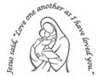
Our Lady’s Catholic Primary School
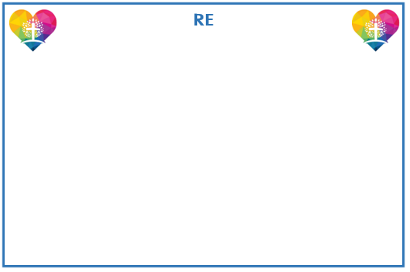
EYFS Curriculum Newsletter: Spring 2025
Spring 1:
Bears, Bears, Bears
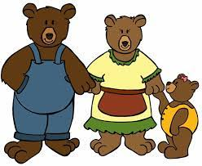
Spring 2:
Growing

Our RE topics this term are Galilee to Jerusalem and Desert to Garden. Children will be sharing what we have seen and heard about the story of The Wise Men and of Jesus welcoming the children and feeding the crowd. We will be wondering how we can be more like Jesus and welcome people into our lives. We will be visiting the Church for our Ash Wednesday service and learning why Lent is such an important time. We will be learning the hymns This Little Light of Mine and Shine Jesus Shine.

.
Children will have lots of opportunities to count a range of natural objects and mathematical equipment such as numicon and cubes. We will continue to work on the concept of subitising so that when children look at a small group of dots, for example, they will not need to count them but just say what they see. We will be comparing numbers within 10 and working on 1 more/1 less.


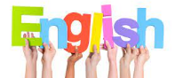
Understanding the World


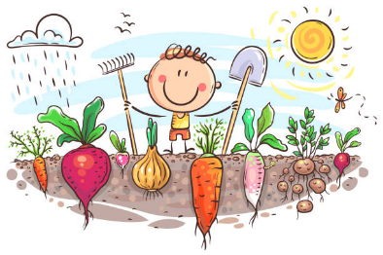
Our focus texts this term are Biscuit Bear, We’re Going on a Bear Hunt, Errol’s Garden and Hungry Hen. We will use these texts to gain a good understanding of story structure and to learn new vocabulary. Children will be encouraged to read cvc words and simple sentences independently and show a good understanding of what they have read. Children will have lots of opportunities to develop writing skills such as writing lists, recipes, and cards.
We will be exploring how things were different in the past and comparing old and new teddy bears. We will also be making maps and describing journeys within our local environment. We will continue our outdoor learning sessions in the forest and will be comparing different plants and animals.



Expressive Arts and Design
.
We will be mixing colours to produce different shades and combining materials to create different textures. We will be making up stories through role play and small world play.
Reminders
We will continue our outdoor learning in the forest every Thursday - children need wellies every week as it can get very muddy! Hats and gloves are handy too!

Watch this Space!
PE lessons will begin after February half term.
Physical Development
We will begin PE lessons after the February half term (more information to follow) During PE lessons we will be focusing on developing control and balance when using large apparatus. We will also be developing our gross motor skills by building with large apparatus and making obstacle courses outside. We will be developing our fine motor skills by practising our scissor skills and our pencil control.

Personal, Social and Emotional Development

We will be using a wonderful book called The Colour Monster to encourage children to talk about the emotions we experience and the different ways we can express them. We will also be encouraging children to complete tasks independently.


lknlnk
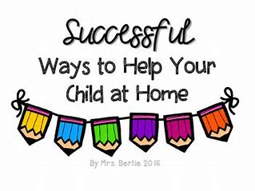
Home Learning Activities
When you have completed a task send it into school to share with the class or we would love to see the photos onClass Dojo.
Use your phonic skills to help a grown up write a shopping list. | Make some number cards and put them on a washing line in the right order. | Draw a picture of your favourite teddy bear and label the different parts.
Get creative and make a map from the story We’re Going on a Bear Hunt | Share the bible story The Feeding of the Five Thousand. Make some bread together. | Plant a seed and watch it grow.  Write a set of instructions of how to plant a seed.

Reading
In order to encourage your child to become a lifelong reader, it is important that reading experiences are positive. Reading to your child, sharing books with and listening to your child read with lots of encouragement and praise
are so valuable.
All children will bring home a reading book each week. If your child is following our Little Wandle Phonics programme, they will bring home a fully decodable Big Cat book. If your child has successfully completed the programme, they will be reading books from our Oxford Reading Tree scheme before moving to our selection of Free Readers.
All children will also bring home a free choice book from our School Library to share and read with your help.



