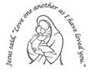
Our Lady’s Catholic Primary School
Year 1 Curriculum Newsletter: Spring Term 2025
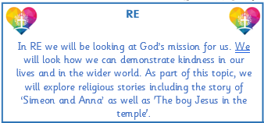
Discovering the World

Our topic this term is called Discovering the World. We will be finding out about the U.K and our local area.


We will continue each morning to develop the children’s arithmetic skills through a set of questions consolidating skills already taught.

This half term, we will be looking at Number and Place Value within 20 and then to 50! Within this topic we will focus upon both Addition and Subtraction. There will also be an opportunity for the children to explore Length, Height, Mass and Volume.

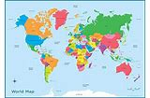


Humanities
This term’s focus is Weather in the U.K. Learning will include using maps to learn about the countries within the UK and how the weather changes through the seasons. In History, we will be looking at toys in the past and present.

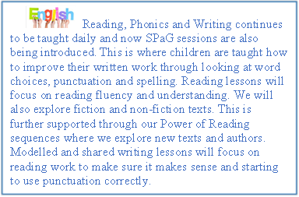

Phonics and Reading skills will continue to be developed through a range of learning opportunities during our daily Reading Workshops. Immersive Reading sessions will focus on texts and will allow the children to engage with the story, explore themes and issues and develop creative responses. Clever Writer lessons focus on the development of skills (ingredients) required to write. Writing checklists are used daily so that children practise, apply and embed skills that are taught.


Creative Learning

Art lessons will be focus on the work of Jasper
Johns and his use of colour and colour mixing.
In DT, we will be making puppets in a variety of ways using different materials. Music lessons will be developing our singing voices.
Reminders
PE days:
Tuesday and Thursday.
Full PE kit to be worn to school.

Reminders
No earrings for PE days.
Library Books will be changed every Friday.



PSHE
Our themes during PSHE lessons will focus upon ‘Keeping safe’. Within this unit we will discuss who can help us and the importance of super sleep!
This term, we will be developing an understanding of seasonal changes and how they affect us. We will be looking closely at naming the four seasons and what makes then unique.

Spring Term Home Learning Project
Please complete at least three of these tasks by Friday 7th March 2025
The best way to manage your time will be to complete one task per week.
As soon as you have completed a task, bring it into school to share with the class.
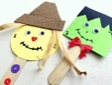    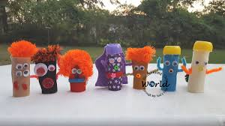 |  | 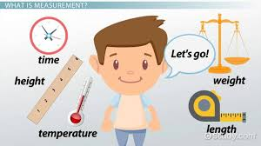
Try making a puppet at home! We will be exploring fabric puppets in school but what else could you use? | Do you know all the months of the year? Can you say them in order? Do you know which month your birthday is in? | In maths, we will be doing measuring in lots of different ways. How many ways can you measure at home?
 | 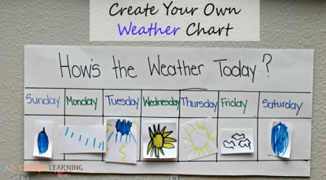 | 
In Art, we will be exploring colours, mixing and creating new colours. Try mixing colours at home, can you make brown or purple ? | Make a weather chart for your house. Record the weather every day for your local area for 2 weeks. Bring in your chart to show us. | WILD CARD: Use your imagination and surprise us!
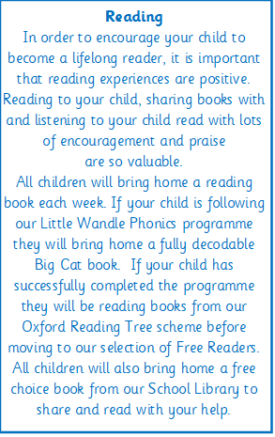

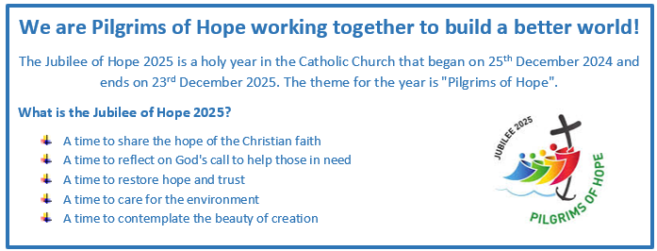
Healthy child, Healthy mind!



