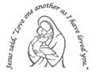
Our Lady’s Catholic Primary School
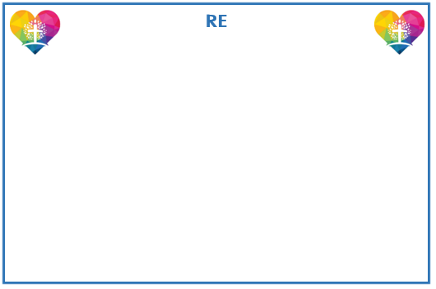
Year 2 Curriculum Newsletter: Spring Term
Children should be able to recognise coins based on their real-life experience, as well as earlier learning in Year 1. They will use their knowledge from place value and addition and subtraction to find the total value of a set of coins, with all answers being less than £1. Children make the connection between repeated addition and multiplication and explore equal and unequal groups, so that they are able to identify equal groups for multiplication. Children will calculate mathematical statements for multiplication and division within the multiplication tables and write them using the multiplication (×), division (÷) and equals (=) signs.
Wonderful world

Our focus this term will be all about the world we live in! We will be learning more about the continents and oceans and the differing habitats within them. We will find out about important events that changed the lives of everyone around the world.

Year two are now using the RE scheme which focuses on four areas – Hear, Believe, Live and Celebrate. Each focus begins with children hearing the scripture then learning about the Catholic belief and teaching related to it. Then children will understand how Catholics respond to the scripture and belief in their daily lives, including how they can live it out themselves. Finally, children can express their wonder and awe and learn to pray, praise and celebrate their faith. The Units for this term are Prophecy and Promise and Galilee to Jerusalem.
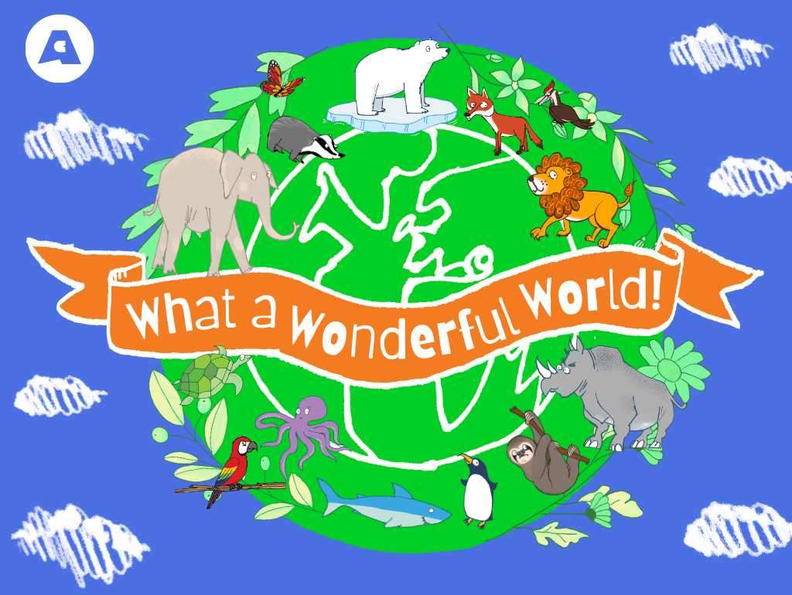

Humanities
History will be about discovering the important events surrounding the history of flight. They will explain how a significant event has changed the lives of others and ask questions about people and events in the past, using primary sources. In Geography lessons we will be answering the question – Why is our world Wonderful?


Reading, writing and spelling continues to be taught daily. Reading lessons will
focus on segmenting and blending, reading fluency and accuracy as well as skills to further develop comprehension. This will be further supported through our ‘I am a clever writer’ teaching sequences which focus on journeying through a text. Modelled and shared writing lessons lead to the children retelling stories, writing diaries, recounts and letters.


Creative Learning
In Art, we will be learning about primary and secondary colours, colour mixing & creating textures using different tools. In DT, children will explore the stability of different structures then design & test a chair suitable for baby bear.

Our PE days are Wednesday and Friday

Please ensure full school PE kit of plain navy or black tracksuits are worn with suitable trainers. No earrings to be worn on PE days.


The units for this term are Habitats and Microhabitats. We will begin by looking at life processes and how to identify living things. Then focus on how animals use their habitat for food and shelter. Children will understand that plants make their own food and talk about food chains.


PSHE
Our themes during PSHE lessons will focus upon keeping safe, appropriate touch and medicine safety.
lknlnk

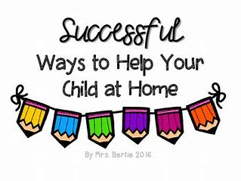
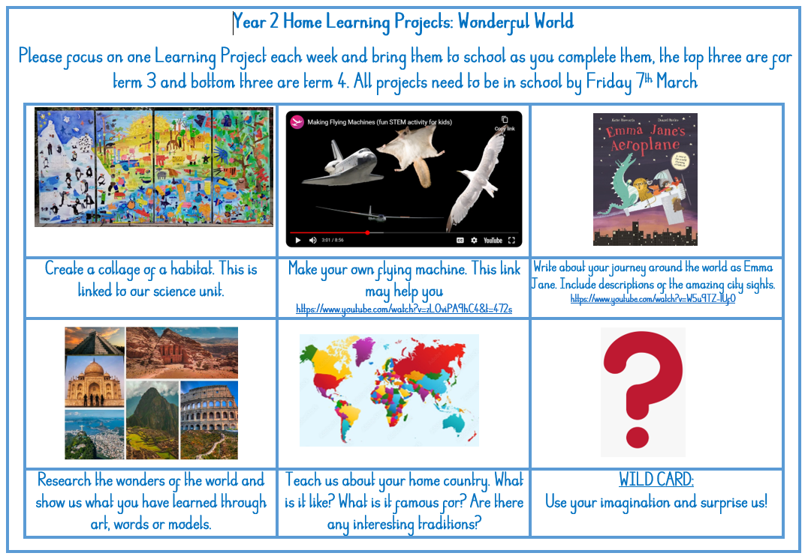

Reading
In order to encourage your child to become a lifelong reader, it is important that reading experiences are positive. Reading to your child, sharing books with and listening to your child read with lots of encouragement and praise
are so valuable.
All children will bring home a reading book each week. If your child is following our Little Wandle Phonics programme, they will bring home a fully decodable Big Cat book. If your child has successfully completed the programme, they will be reading books from our Oxford Reading Tree scheme before moving to our selection of Free Readers.
All children will also bring home a free choice book from our School Library to share and read with your help.

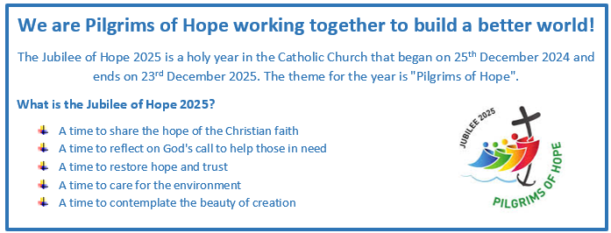
Healthy child, Healthy mind!



