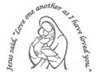
Our Lady’s Catholic Primary School
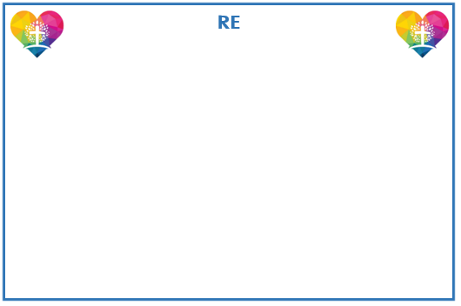
Year 3 Curriculum Newsletter: Spring Term

We will start the term focusing on multiplication and division to consolidate our understanding and become more fluent. We will then explore Measurement, focusing on Length and Perimeter before we learn more about Number and Fractions! We will also begin to look at Mass and Capacity. Please encourage your child to regularly access their TT Rock Stars account. This will create a solid foundation of their times table knowledge.

Judaism: we will learn about the features of a Synagogue and what is special to Jewish people.
Journeys: We will explore a journey throughout the year before learning about the Christian family’s journey with Jesus through the Church’s year.
Listening and Sharing: We will explore how being thoughtful for life, for people and for gifts is a vital part of our relationships with one another.
Giving and Caring: We will learn about ways in which life, especially family life or life in school, is full of opportunities for self - giving.
THE EMPIRE
Over the course of the term, the children will look at the Roman Empire. They will become historians exploring the impact of the Roman Empire on the world. We will investigate how the Roman’s invaded and settled in Britain and how the Celts reacted to this.

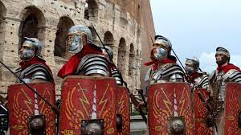
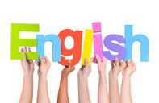
Humanities
This term’s focus is the Romans. During History lessons, we will look at what life was like during the time of the Roman Empire and the impact that it had. In Geography, we will then focus on different types of land use and settlements.
We will continue to focus on Reading, Writing and Phonics each day. Reading lessons will focus on reading fluency, speed and accuracy as well as skills to further develop comprehension skills. We will look at new skills in writing such as using direct speech, similes, other verbs for said and using apostrophes. Children will be given many opportunities to plan, draft, edit and improve their writing for various purposes, such as persuasive writing, narrative writing and information texts.



Reminders
PE Days are Monday and Friday for both classes.
Full PE kit to be worn to school.

Creative Learning
In Art, we will be developing our drawing skills by looking at still life drawings. We will learn to shade and create texture.
In DT, we will be looking at how to create strong structures and create nets. We will end by creating our own castles.


Firstly, we will focus on ‘Rocks and Soil.’ Children will investigate different types of rocks and learn about how fossils are made. We will then observe the links between light and dark, explore reflections and learn how shadows are created.
PSHE
Our themes during PSHE lessons will focus on ‘Safe or Unsafe’ and ‘Helping each other to stay safe.’ We will explore many issues and scenarios and discuss multiple ways to keep safe,



lknlnk
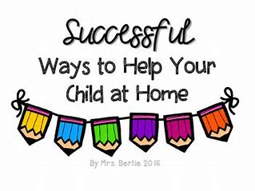
Settle Down Home Learning Project
Please complete each task over the term at home and have them in school by 7th March.
The best way to manage your time will be to complete one task per week.
As soon as you have completed a task, bring it into school to share with the class.
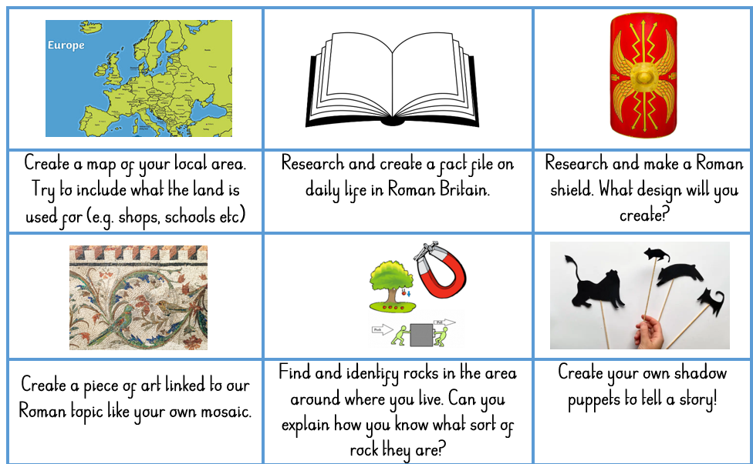
Reading
In order to encourage your child to become a lifelong reader, it is important that reading experiences are positive. Reading to your child, sharing books with and listening to your child read with lots of encouragement and praise
are so valuable.
All children will bring home a reading book each week. If your child is following our Little Wandle Phonics programme, they will bring home a fully decodable Big Cat book. If your child has successfully completed the programme, they will be reading books from our Oxford Reading Tree scheme before moving to our selection of Free Readers.
All children will also bring home a free choice book from our School Library to share and read with your help.

Healthy child, Healthy mind!



