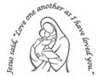
Our Lady’s Catholic Primary School

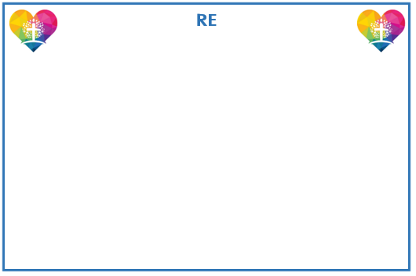
Year 4 Curriculum Newsletter: Spring 2025

Focussing on Multiplication and Division, the children will apply it to daily situations and reasoning problems. Children will build their knowledge of Fractions and Decimal Numbers.
Through our focus on Measurements unit, childrenwill learn about and practising measuring Length and Perimeter.




Community: Exploring the idea that community is an essential and enjoyable part of life for people of every age and faith.
Giving and Receiving: Being thoughtful for life, for people and gifts. This is a vital part of our relationships with one another, and when praise and appreciation are experienced, we are able to relate on a deeper level.
Self-discipline: Uniting ourselves with Christ in order to grow, through the practices of prayer, fasting and almsgiving.

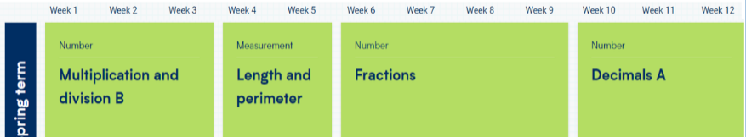

Humanities
In Geography, the children will learn about rivers: their place in the water cycle, the name and location of major rivers and how they are used.
In History, children will investigate the changes in children’s lives through time. They will explore work in more detail, learning about a day in the life of a working child and the significance of Lord Shaftesbury.

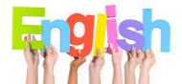
Reading skills will continue to be
developed through a range of learning opportunities during our daily Reading Workshops. Immersive Reading sessions will focus on the text: Arthur and the Golden Rope and will allow the children to engage with the story, explore themes and issues and develop creative responses.
Clever Writer lessons focus on the development of skills (ingredients) required to write. Writing checklists are used daily so that children practise, apply and embed skills that are taught.
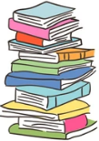

Reminders

Reading:
Please listen to your child read each day, help them to notice and correct any errors and fill in the Reading Record.

PE days:
Wednesday and Thursday.
Full PE kit to be worn to school on those days.


Creative Learning
The children will explore how different materials can be shaped and joined and learn techniques used by artists before creating their own sculptures.
In DT, children will adapt an existing biscuit recipe while considering the cost of ingredients and other expenses against a set budget.



The children will learn about states of
matter by investigating the properties of solids, liquids and gases. They will explore changes of state through relatable examples, explain the water cycle changes and study how the temperature affects the rate of evaporation.




PSHE
Our themes for PSHE this term will be based around managing risk, Online Safety and ways we can make a difference to other by helping or the environment. We will also explore Media influence.

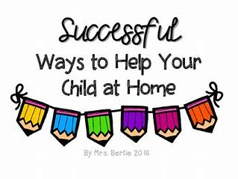
Reading
In order to encourage your child to become a lifelong reader, it is important that reading experiences are positive. Reading to your child, sharing books with and listening to your child read with lots of encouragement and praise
are so valuable.
All children will bring home a reading book each week. If your child is following our Little Wandle Phonics programme they will bring home a fully decodable Big Cat book. If your child has successfully completed the programme they will be reading books from our Oxford Reading Tree scheme before moving to our selection of Free Readers.
All children will also bring home a free choice book from our School Library to share and read with your help.
Home Learning Projects
Complete each task over the term at home. Manage your time by completing one task per week. As soon as you have completed a task, bring it to school to share with the class.
All projects to be completed by Friday 7th March.

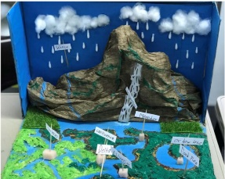 | 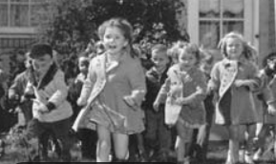 | 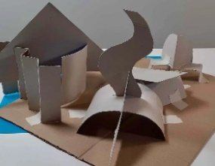 | 
Make a model to explain your understanding of Rivers and  the water Cycle. | Write a report or facts explaining how children lived  in the past. | Use your sculpting skills to make a model linked to any of our Year 4 Topics. | Design and make a recipe. Write out the ingredients and method. Take photos of the end product!
 |  | 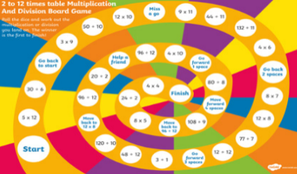 | 
Make a poster or a leaflet about the importance of how we can stay safe online | Use your fabulous Clever Writer skills to write a story of  your choice. | Make your very own Maths game. You can focus on any of the Maths we are learning this term. | This is your opportunity to decide what you would like to find out and present!


