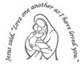
Our Lady’s Catholic Primary School
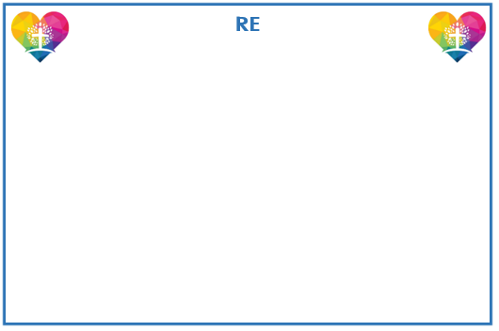
Year 5 Curriculum Newsletter: Spring Term

The children will explore Multiplication and Division. This will be followed by a unit on Fractions. For the second half of the term, our focus will be on Decimals, Percentages, Perimeter and Area and Statistics.

Influence and Change

Why do oceans
matter?
The key question above will be our focus in Geography for this term and to which all our learning will be linked. We will need to apply our prior learning, analyse sources and complete our own research.

We are applying the new RE curriculum, which for this term covers Branch 3: Galilee to Jerusalem.
In this branch, pupils will explore the ‘new law’ given by Jesus, his summary of the law of Moses, and the transfiguration of the Jesus, where the disciples Peter, James and John see him accompanied by Elijah, the greatest of the prophets and Moses, the giver of the Law. Pupils will also look at how Jesus shows the love of neighbour in action through one of his parables and the Our Father as the perfect prayer and summary of the whole gospel.



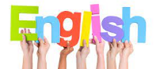

Reading and writing continues to be taught daily. Reading lessons will focus on reading fluency, speed and accuracy as well as skills to further develop comprehension. Writing will be taught through our “I am a Clever Writer” scheme. The books we will focus our writing on are “The Dam” and “The Storm Whale.” Modelled and shared writing lessons lead to the children having the opportunity to plan, draft, edit and improve their writing.


Humanities
The history focus in the second half of the term will be based on the Tudors. What was life like in Tudor Times?
This key question will be the focus for our learning.




PSHE
Our themes during PSHE lessons will focus upon Safety, Caring, Achievement, Resilience and Friendship.
Reminders
PE days: Wednesday and Friday.
Full PE kit to be worn to school.

Our focus is Materials: Mixtures, Separation,
Properties and Changes
Children will learn about what a mixture is and the methods in which they can be separated. They will also cover properties and changes in materials, building on the work from previous years.



Creative Learning
During Art lessons, the children will study portraits using painting and mixed media. In DT, the children will be completing a unit on cooking and nutrition, focussing on Bolognese recipes.

lknlnk

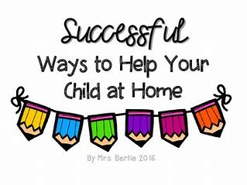
Year 5 Spring Term Project Tasks.
Please complete at least four of these tasks before Friday 7th March.
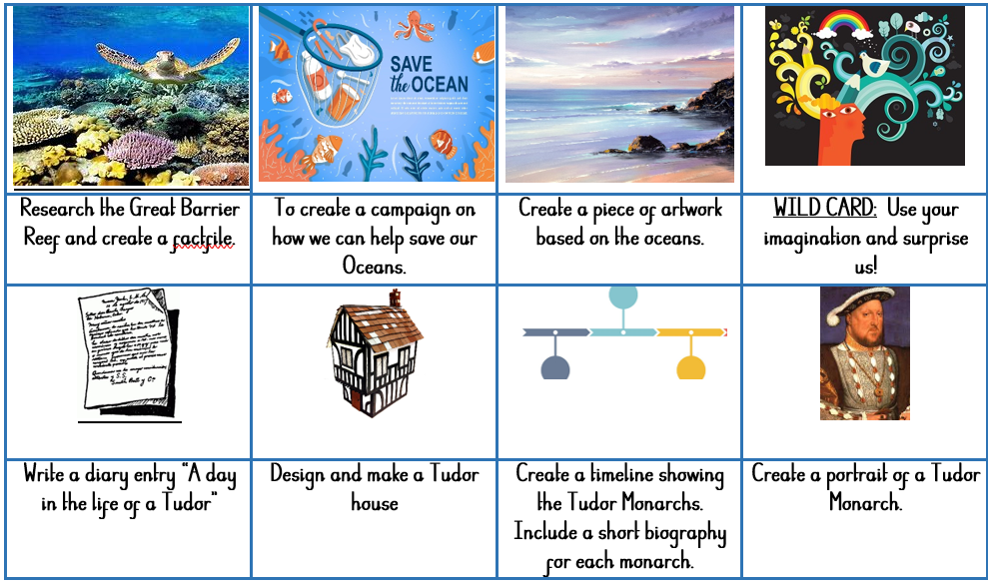
Reading
In order to encourage your child to become a lifelong reader, it is important that reading experiences are positive. Reading to your child, sharing books with and listening to your child read with lots of encouragement and praise
are so valuable.
All children will bring home a reading book each week. If your child is following our Little Wandle Phonics programme they will bring home a fully decodable Big Cat book. If your child has successfully completed the programme they will be reading books from our Oxford Reading Tree scheme before moving to our selection of Free Readers.
All children will also bring home a free choice book from our School Library to share and read with your help.

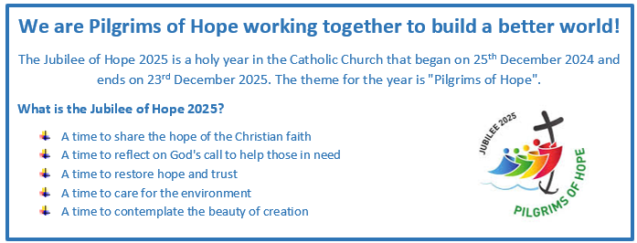
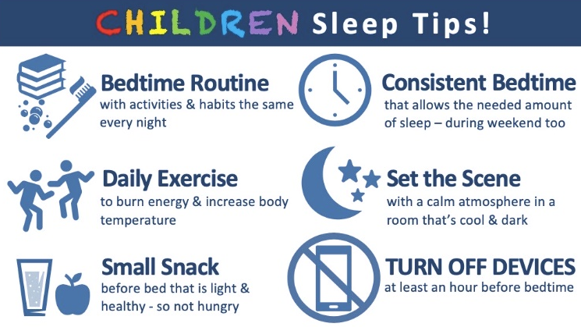
Healthy child, Healthy mind!

