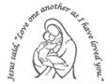
Our Lady’s Catholic Primary School
Year 6 Curriculum Newsletter: Spring Term

We will start the term with a unit on ratio. This will be followed by a unit on algebra and decimals.
In the second half of the term, our focus will be fractions, decimals, and percentages followed by a unit on area, perimeter, and volume. We will then end the term by looking at statistics.

RE


POWER UP!

How does using power affect climate change?
This will be our key question for this term which all our learning will be linked to. We will need to apply our prior learning, analyse sources and complete our own research.


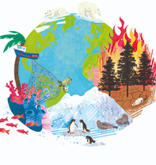
Within our RE this term, the children will learn all about Prophecy and Promise then Galilee to Jerusalem. The children will explore key scripture, talk openly as well as being able to think critically and creatively.


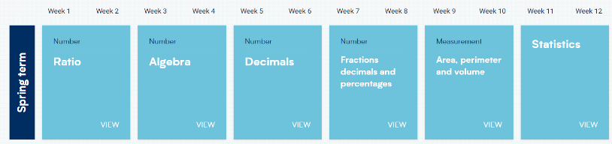
Humanities
The History unit gives the children the historical skills of inference, extracting information from sources, evaluating historical figures and the opportunity, like historians, to decide their criteria for significance. In Geography they explore global population, birthrate and migration and explore human and physical processes.

Reading, writing and spelling continues to be taught daily. Reading workshops will focus on reading fluency, speed and accuracy as well as skills to further develop comprehension. The books we will focus our writing around are “The Highwayman” and “Princess’ Blankets.” Modelled and shared writing lessons lead to the children having the opportunity to plan, draft, edit and improve their writing.
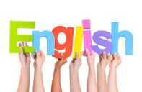

Reminders
PE days: Tuesday and Wednesday.
Full PE kit to be worn to school.
Weekly homework is set in their revision books. Children are also expected to access spelling shed, WWN, spag.com and TTRS. Reading daily is also a requirement with their reading record signed.
Creative Learning

In Art, the children will discover all about impact art and create an inspired impact piece. In D&T, they will explore structures, tools and the properties of wood to make a playground prototype and structure.

In Science, our focus of study is on Living things and Evolution and Inheritance. The children will use their knowledge to classify and give the name of the group and one additional characteristic. They will also learn about variation, adaption and carryout many investigations.

Safety, Caring, Achievement, Resilience, Friendship
Our themes during PSHE lessons will focus on keeping safe and rights and respect.

Year 6 Tudor Project Tasks.
Please complete at least four of these tasks before 17th March.
As soon as you finish a task please bring it into school to share with your class!
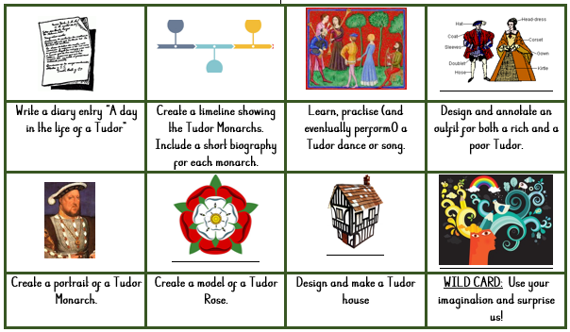

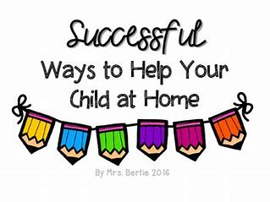
Year 6 POWER UP Project Tasks.
Please complete at least four of these tasks before Friday 7th March.
Reading
In order to encourage your child to become a lifelong reader, it is important that reading experiences are positive. Reading to your child, sharing books with and listening to your child read with lots of encouragement and praise
are so valuable.
All children will bring home a reading book each week. If they are working on decoding their book will be fully decodable. If your child has successfully completed our phonics programme, they will be reading books from our Oxford Reading Tree scheme before moving to our selection of Free Readers.
All children will also bring home a free choice book from our School Library to share and read with your help.
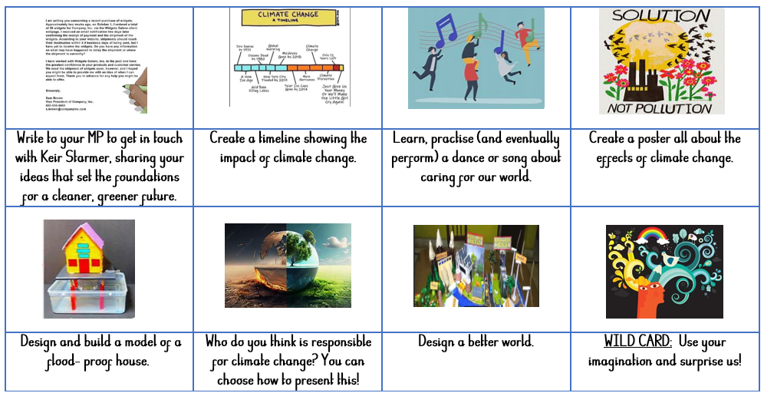

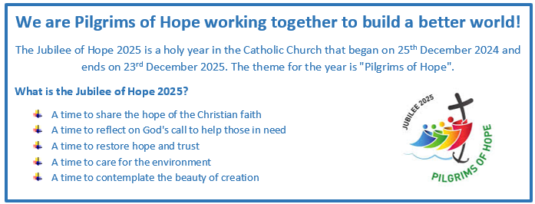
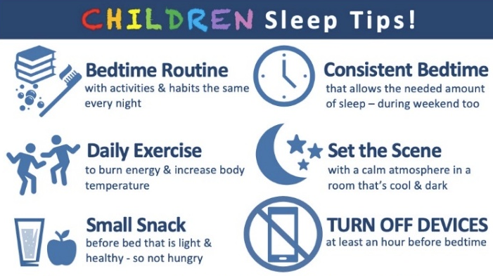
Healthy child, Healthy mind!

